3 QUIZZES (10%)

**CS330 - 001 INTRODUCTION TO OPERATING SYSTEMS • WINTER SEMESTER 2020**

**INSTRUCTOR: ANDRÉ DOS SANTOS**

**dossantos@cs.uregina.ca • andreeds.github.io**

horizontal line

**QUIZZ 1: January 30th, 2020 - 9:45 am**

**QUIZZ 2: February 27th, 2020 - 9:45 am**

**QUIZZ 3: March 31st, 2020 - 9:45 am**

horizontal line

**THE QUIZ**

* Duration: 24 hours
* Content: All the material covered up to the date of the Quiz
* Marking: The quizzes are weighted equally
* Questions: Each question start with a 100% mark. For each wrong answer, the next attempt is worth 10% less. That means you can attempt 9 times until obtaining 0% marks.

**QUIZ STRUCTURE**

* The quiz is split into blocks:
  + Example: **QUIZ TEST A** is a block, **QUIZ TEST B** is a block

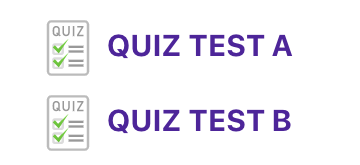

* All blocks are enabled at the same time, but the password for the following block is placed at the end of the previous block
  + Example: At the end of block **QUIZ TEST A** is the password to access block **QUIZ TEST B**

**ANSWERING THE QUIZ**

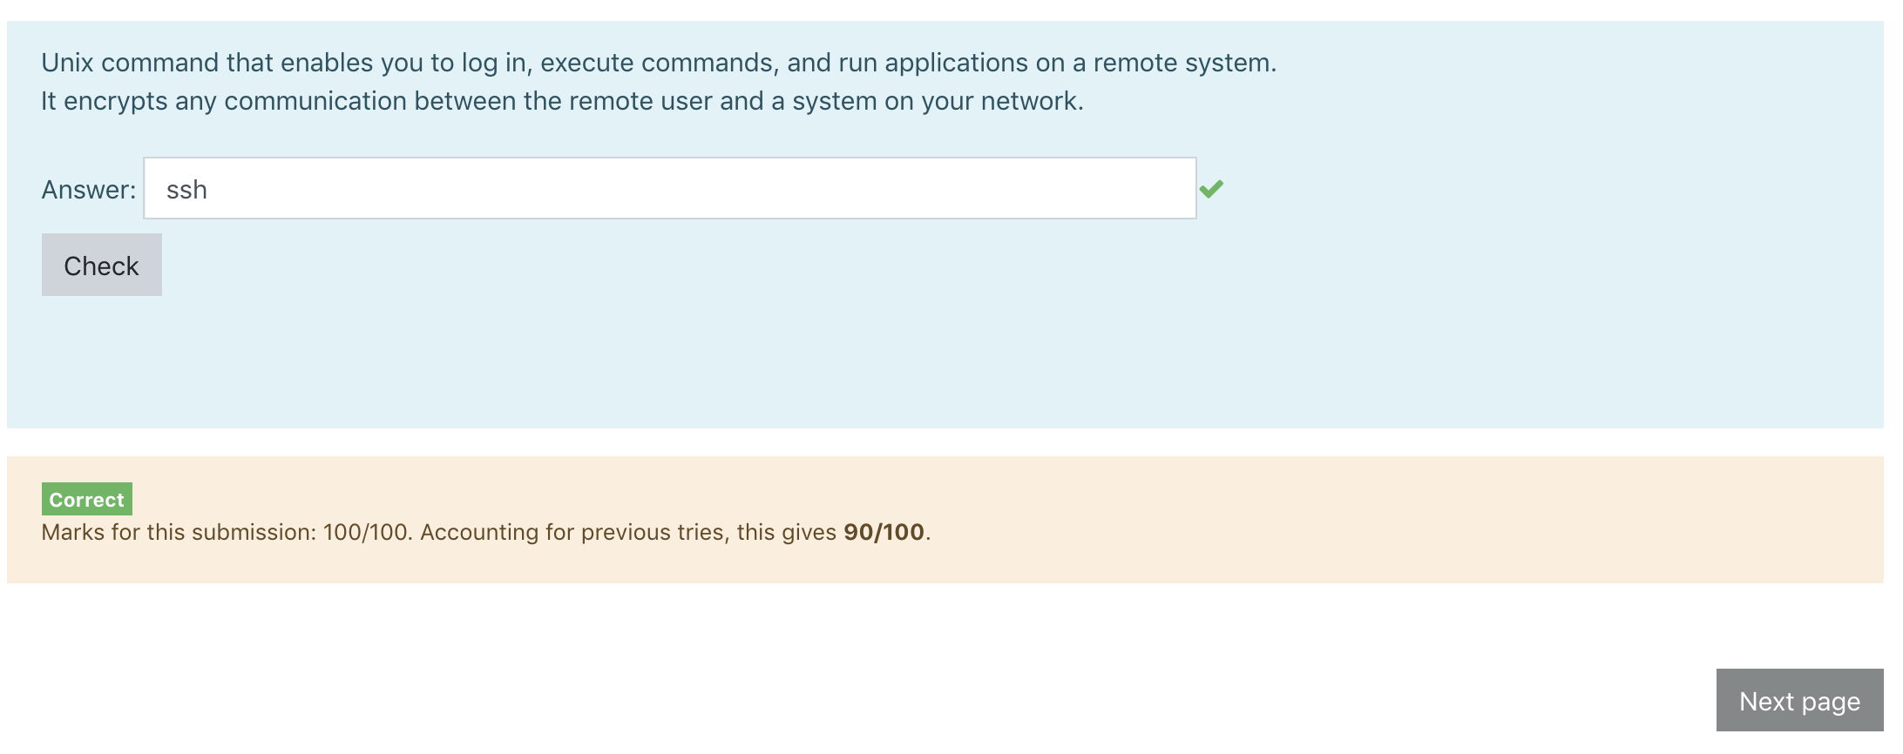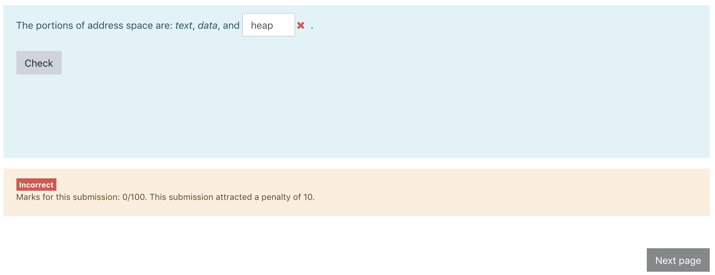

* All questions answers are short answer, NOT case sensitive.
* **To attempt a reply click "Check", NOT "Next Page"**
* **Once clicked "Next Page" YOU CANNOT COME BACK TO THE PREVIOUS QUESTION**

**THE COMPETITION**

* The score of each PERSON is determined by the following equation:

$Score = \sum_{Q}{} M*TimeScoreBase$

where

* $M$ is the **mark**
  + $100\%$ if no wrong answers
  + $1.0 - exp((1.0-value))/exp(1)$ otherwise
* $T$ is the time scored obtained $TimeScoreBase= TimeScoreBase * pow(A, BestPlayTime - PlayTime);$

$ManipulatorScore = ManipulatorScoreBase *$

$pow(B, BestManipulatorCount - UsedManipulators);$

$T = sqrt(TimeScore * ManipulatorScore);$

**THE BONUS**

Final scoreboard once all quizzes have occurred.

**1st (first 5) +5%**

**2nd (next 10) +3%**

**3rd (next 10) +2%**

**4th (remaining) +1%**